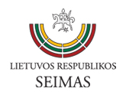
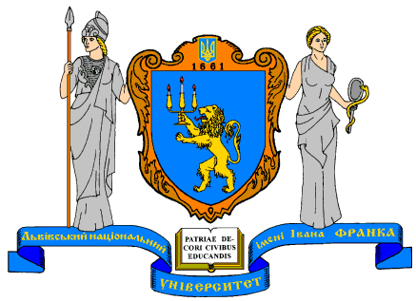
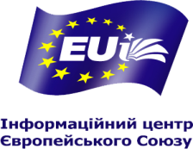

The European Information Office of the Seimas of the Republic of Lithuania
EU Informational Center of Ivan Franko National University of Lviv
Institute of International Relations and Political Science of Vilnius University

LITHUANIAN EXPERIENCE IN IMPLEMENTING THE EU ASSOCIATION AGREEMENT: HOW TO BUILD AN EFFECTIVE INFORMATION eNVIRONMENNT IN UKRAINE

VIDEO CONFERENCE
Vilnius – Lviv
20 March 2015 at 14:00
Press Conference Hall, Building II of the Seimas
Conference room of the Faculty of International Relations of Ivan Franko National University of Lviv (room 205)

The information environment in the process of Ukraine’s Europeanisation is of utmost importance in the current politico-economic domestic and international context. The issue of an effective information environment is topical for Lithuania as well.
The signing of the Association Agreement and Deep and Comprehensive Free Trade Agreement demonstrated the resolve of the Ukrainian authorities to reform the country. The results of the opinion polls, conducted on 15 January 2015, showed that the majority of the Ukrainians (56%) are positive about the Association Agreement with the EU. However, only 38% of Ukrainian population believe they know enough to decide whether to support the Agreement as a part of national reforms. How to build up an effective information environment that enhances Ukraine’s transformation according to the European civilization model? What are the key elements of effective information environment? How to start forming the country’s social immunity to Russia’s information war? These and other relevant questions are to be discussed on 20 March 2015 during the first video conference organised by the Seimas European Information Office and the Faculty of International Relations, Ivan Franko National University of Lviv.
Working language – English
Duration -1.5 hours
More information at www.eib.lrs.lt; http://eui.lnu.edu.ua/index.php
Contacts: eui.lviv@gmail.com

PROGRAMME

13.30– 14.00 | Registration  Lithuania: Press Conference Hall, Building 2, Seimas of the Republic of Lithuania Gedimino pr. 53, Vilnius, Lithuania  Ukraine: Conference room of the Faculty of International Relations of Ivan Franko National University of Lviv, 19, Sichovyh Striltsiv st., Lviv, Ukraine
14.10 – 14.20  14.20 – 14.30 | Russian propaganda offensive: reality check  Dr Nerijus MALIUKEVIČIUS, Vilnius University, International Relations and Political Science Institute  The problem of effective media coverage of implementing the EU-Ukraine Association Agreement  Assoc. Prof. Igor IZHNIN, Ivan Franko National University of Lviv, Department of International Relations and Diplomatic Service
14.30 – 14.35  14.35 – 14.40 | Contribution  Mr Audronius AŽUBALIS, Deputy Chair of the Foreign Affairs Committee of the Seimas of the Republic of Lithuania  Mr Vyacheslav VOYNAROVSKIY, Representative in Lviv of the Ministry of Foreign Affairs of Ukraine
14.40 – 15.00  15.00 – 15.20 | Debate  Moderator Mr Petras AUŠTREVIČIUS , member of European Parliament  Moderator Mr Markiyan MALSKIY, former Ambassador of Ukraine to Poland
15.20 – 15.25  15.25 – 15.30 | Concluding remarks  Mr Vykintas PUGAČIAUSKAS, International news editor at Lithuanian National Radio and Television  Mr Taras BYK, analyst of International Republican Institute in Ukraine, Kyiv
15.30 – 15.35  15.35 – 15.40 | Closing remarks  Mr Petras AUŠTREVIČIUS, member of European Parliament  Mr Markiyan MALSKIY, former Ambassador of Ukraine to Poland

